EXPERIMENT NO. 24
AIM
To model clock-driven concurrent processes using SC_THREAD and wait() in SystemC.
ALGORITHM
- Create a SystemC clock.
- Create an SC_THREAD process sensitive to the positive clock edge.
- Display a message whenever the clock triggers the process.
- Run the simulation for 5 ns.
PROGRAM
#include <systemc.h>
SC_MODULE(ClockExample)
{
void process()
{
cout << "Time: " << sc_time_stamp()
<< " - Clock Triggered" << endl;
}
SC_CTOR(ClockExample)
{
SC_THREAD(process);
sensitive << clk.pos();
}
sc_in<bool> clk;
};
int sc_main(int argc, char* argv[])
{
sc_clock clock("clock", 1, SC_NS);
ClockExample module("module");
module.clk(clock);
sc_start(5, SC_NS);
return 0;
}
OUTPUT
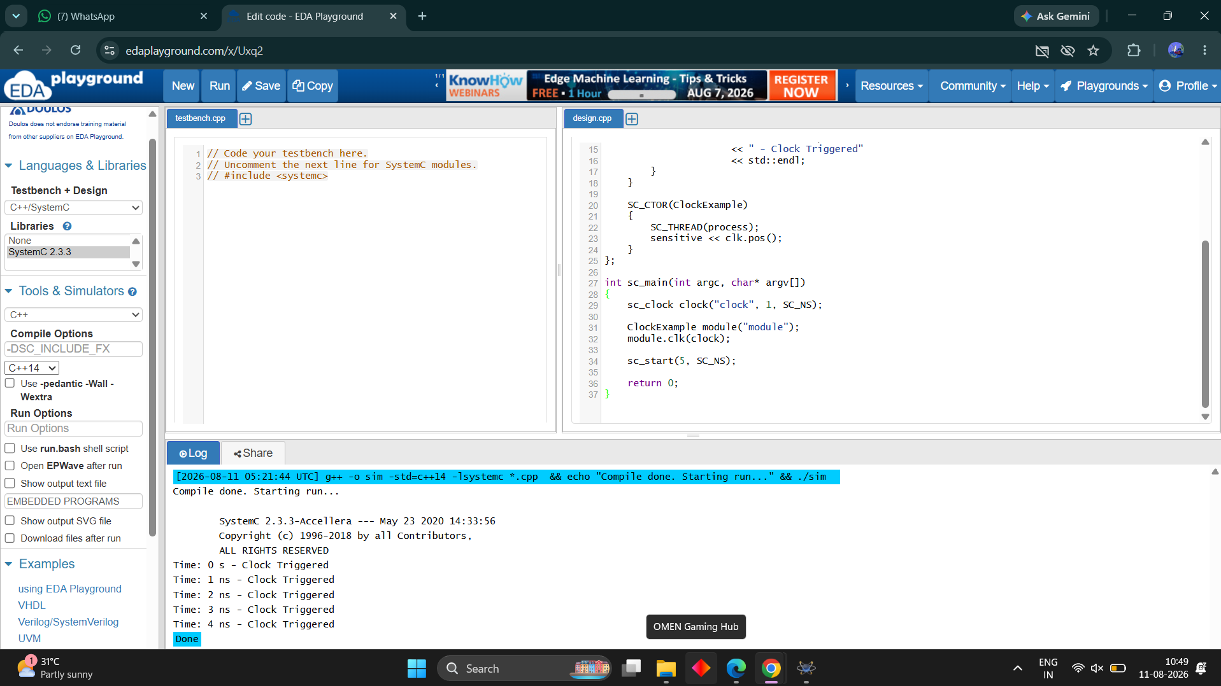
RESULT
Thus the clock-driven concurrent process using SC_THREAD and wait() was successfully modeled and executed.

